Cointegration and ECM: NZDUSD and USDCHF
Method 27 / Engle-Granger on log closes / one-lag ECM / Alpari D1 full available history

Study setup
Logical pair: PX=NZDUSD , PY=USDCHF
Broker symbols: NZDUSD_i , USDCHF_i
Snapshot: 2026-11-03_majors_alpari_D1
Timeframe: D1
Matched window: 1999-01-05 to 2026-11-02 (UTC bar dates)
Matched level count n: 7185
Dropped unfinished last bar dated 2026-11-03 UTC after a tick-volume check against the prior complete day.
ECM lags of deltas: 1
Complete matched rows (Excel): NZDUSD-USDCHF_Coint_D1.xlsx
Complete matched rows (HTML table): NZDUSD-USDCHF_Coint_D1_data.html

Method carried forward
Engle-Granger cointegration works on log price levels, not returns. For each unordered pair, PX is the left leg and PY the right leg. Step one: OLS ln(PY) = alpha + beta * ln(PX) + e. Step two: statsmodels Engle-Granger coint test on (ln(PY), ln(PX)). Error-correction: delta ln(PY)_t = c + kappa * e_{t-1} + lagged delta ln(PY) and delta ln(PX) (one lag each) + u_t. Headline is the Engle-Granger p-value (lower = stronger evidence of a stationary spread) with kappa and beta reported alongside. Same-sample Pearson r of log returns is a side check only. beta is not an automatic lot-size hedge. This is not a trading signal.

Results (headline)
alpha: -0.275443
beta: -0.792241
Engle-Granger t: -0.748202
Engle-Granger p: 0.941179
5% critical value: -3.336981
ECM kappa: -0.000425
kappa t-stat: -0.8635
ECM R^2: 0.001960
spread std: 0.158052
Pearson r (returns): -0.393600

Conclusion
Engle-Granger for PY=USDCHF on PX=NZDUSD: beta=-0.7922, alpha=-0.2754, coint_t=-0.7482, p=0.9412 (5% crit=-3.3370). ECM kappa=-0.0004 (t=-0.86). Pearson r of returns = -0.3936. beta is not a lot-size hedge. Not a trading signal.

Charts
Daily closes

Engle-Granger residual spread
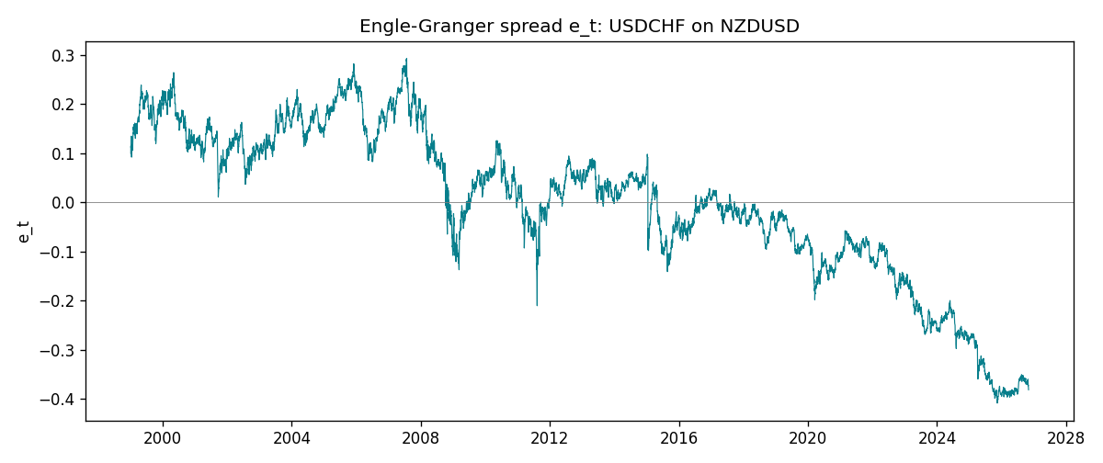
Daily log returns
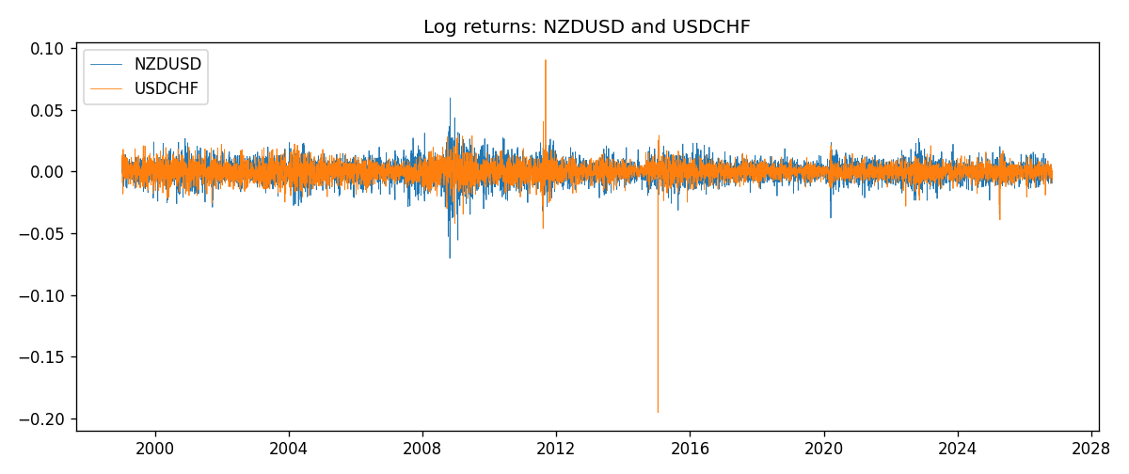

Data report
Matched rows are in the sibling Excel workbook named NZDUSD-USDCHF_Coint_D1.xlsx. Embedding all rows as a Word table is impractical; this file holds column summaries and the first and last 15 matched rows.
Column summaries
column | count | mean | std | min | 25% | 50% | 75% | max
NZDUSD_open | 7185 | 0.65641395 | 0.10821881 | 0.3913 | 0.59137 | 0.6684 | 0.72499 | 0.88218
USDCHF_open | 7185 | 1.0976269 | 0.25248305 | 0.72022 | 0.92053 | 0.98988 | 1.2378 | 1.8219
NZDUSD_high | 7185 | 0.66033247 | 0.10871106 | 0.3961 | 0.59478 | 0.672 | 0.72937 | 0.88421
USDCHF_high | 7185 | 1.1029176 | 0.25422469 | 0.73305 | 0.92474 | 0.99353 | 1.2423 | 1.8313
NZDUSD_low | 7185 | 0.65272894 | 0.10781325 | 0.3897 | 0.58811 | 0.66417 | 0.72099 | 0.87988
USDCHF_low | 7185 | 1.0925083 | 0.25089773 | 0.08565 | 0.91719 | 0.98622 | 1.2317 | 1.8121
NZDUSD_close | 7185 | 0.65649284 | 0.10821292 | 0.3907 | 0.59165 | 0.6684 | 0.72502 | 0.8822
USDCHF_close | 7185 | 1.0976163 | 0.25237603 | 0.72025 | 0.92079 | 0.98995 | 1.2379 | 1.8217
NZDUSD_tick_volume | 7185 | 68718.644 | 123140.12 | 16 | 5587 | 33899 | 58511 | 1127682
USDCHF_tick_volume | 7185 | 74335.19 | 113494.16 | 18 | 12810 | 40241 | 70443 | 858589
NZDUSD_spread | 7185 | 30.278775 | 25.647496 | 0 | 9 | 17 | 40 | 80
USDCHF_spread | 7185 | 26.036326 | 24.697816 | 0 | 5 | 16 | 50 | 100
NZDUSD_real_volume | 7185 | 1.6703703e+10 | 8.4983725e+10 | 0 | 0 | 0 | 0 | 2.705649e+12
USDCHF_real_volume | 7185 | 2.3294091e+10 | 8.9133595e+10 | 0 | 0 | 0 | 0 | 1.9331921e+12
NZDUSD_log_price | 7185 | -0.43560191 | 0.17595018 | -0.93981528 | -0.52484004 | -0.40286848 | -0.32155604 | -0.12533649
USDCHF_log_price | 7185 | 0.06965864 | 0.21073976 | -0.32815691 | -0.08252328 | -0.01010084 | 0.2134164 | 0.59977013
NZDUSD_log_return | 7185 | 2.019e-05 | 0.00763908 | -0.07027433 | -0.0042485 | 0.00023717 | 0.00458461 | 0.05966839
USDCHF_log_return | 7185 | -7.205e-05 | 0.00658891 | -0.19545699 | -0.0033516 | 8.095e-05 | 0.00331593 | 0.09051364
spread_e | 7185 | -0 | 0.15805159 | -0.40895824 | -0.08999355 | 0.01731463 | 0.12334268 | 0.29292721
ecm_fitted | 7184 | -7.261e-05 | 0.00029171 | -0.00412163 | -0.00022309 | -7.091e-05 | 7.694e-05 | 0.00887741
First 15 matched rows (selected columns)
time | NZDUSD_log_price | USDCHF_log_price | spread_e | NZDUSD_log_return | USDCHF_log_return
1999-01-05 | -0.62138481 | 0.31656103 | 0.099717594 | -0.0018597736 | 0.0039424743
1999-01-06 | -0.61933925 | 0.33016668 | 0.11494382 | 0.0020455609 | 0.013605652
1999-01-07 | -0.61304294 | 0.3207783 | 0.11054364 | 0.0062963171 | -0.0093883841
1999-01-08 | -0.6135969 | 0.33181857 | 0.12114503 | -0.00055396548 | 0.011040268
1999-01-11 | -0.60330648 | 0.33711489 | 0.13459385 | 0.010290425 | 0.0052963193
1999-01-12 | -0.60862223 | 0.32728733 | 0.12055493 | -0.0053157489 | -0.0098275602
1999-01-13 | -0.61859645 | 0.30902763 | 0.094393246 | -0.0099742238 | -0.018259701
1999-01-14 | -0.6187821 | 0.30660196 | 0.091820497 | -0.00018564931 | -0.0024256692
1999-01-15 | -0.61952504 | 0.32454424 | 0.10917419 | -0.00074294208 | 0.01794228
1999-01-18 | -0.62138481 | 0.3213586 | 0.10451516 | -0.0018597736 | -0.0031856384
1999-01-19 | -0.61952504 | 0.32128608 | 0.10591603 | 0.0018597736 | -7.2518946e-05
1999-01-20 | -0.61544567 | 0.32851207 | 0.11637386 | 0.0040793678 | 0.0072259871
1999-01-21 | -0.61138288 | 0.3246888 | 0.1157693 | 0.0040627941 | -0.0038232689
1999-01-22 | -0.62343457 | 0.32454424 | 0.1060769 | -0.012051689 | -0.0001445609
1999-01-25 | -0.62698498 | 0.32699893 | 0.10571882 | -0.0035504102 | 0.0024546976
Last 15 matched rows (selected columns)
time | NZDUSD_log_price | USDCHF_log_price | spread_e | NZDUSD_log_return | USDCHF_log_return
2026-10-13 | -0.57755321 | -0.18339413 | -0.36551238 | 0.0047326165 | -0.0024955621
2026-10-14 | -0.58128385 | -0.1804553 | -0.36552912 | -0.0037306483 | 0.0029388325
2026-10-15 | -0.57652037 | -0.19024083 | -0.37154082 | 0.0047634855 | -0.0097855323
2026-10-16 | -0.57077027 | -0.19386391 | -0.37060844 | 0.0057501001 | -0.0036230826
2026-10-19 | -0.56887856 | -0.19022874 | -0.36547457 | 0.0018917133 | 0.0036351779
2026-10-20 | -0.56515862 | -0.19285686 | -0.36515561 | 0.0037199341 | -0.0026281224
2026-10-21 | -0.56206629 | -0.19325713 | -0.36310601 | 0.0030923331 | -0.00040027413
2026-10-22 | -0.56536981 | -0.19806077 | -0.37052683 | -0.0033035227 | -0.0048036381
2026-10-23 | -0.56227683 | -0.19240826 | -0.36242393 | 0.0030929853 | 0.005652514
2026-10-26 | -0.56517622 | -0.19056746 | -0.36288015 | -0.0028993932 | 0.0018407959
2026-10-27 | -0.56544022 | -0.18795741 | -0.36047925 | -0.00026399852 | 0.0026100526
2026-10-28 | -0.57516861 | -0.18897162 | -0.36920069 | -0.0097283914 | -0.0010142111
2026-10-29 | -0.5745467 | -0.19383964 | -0.37357601 | 0.00062190714 | -0.0048680164
2026-10-30 | -0.57435132 | -0.19312369 | -0.37270528 | 0.00019537668 | 0.00071594559
2026-11-02 | -0.57694762 | -0.20026966 | -0.38190814 | -0.0025962955 | -0.0071459744

